The management of Hatman Toy Company is trying to determine how many of each of two toy

items to produce over the coming month to attain maximum profit. Each of the two toys needs

to go through three departments (A: Casting, B: Painting, C: Costume) to be completed. The

following table shows the amount of time (in minutes) each department needs to process each

toy item:

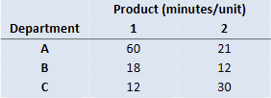

Toy item 1 is sold at $30 profit/unit and toy item 2 is sold at $15 profit/unit. Departments A, B,

and C have a total of 100, 36, and 50 hours of labor time available each month for production.

Write a mathematical formulation of the problem. Clearly define your decision variables, and

write the objective function and constraints algebraically.